Email Copy V2
As we launch into 2025, we set new goals and motivation for the year ahead. As we know, exercise plays a vital role in managing Parkinson’s disease, offering neuroprotective benefits that can slow symptom progression and enhance quality of life.
Tailored exercise programs, including aerobic, strength, and balance training, can significantly impact overall well-being.
Bryan, a recent participant of the PD Warrior 10 Week Challenge says;
"Participating in the PD Warrior 10 week challenge recently has made a profound difference to my Parkinson's symptoms.
Walking normally again with greater energy & ability to do everyday tasks. The course is both extremely challenging & rewarding, all at the same time, and there are many ups and downs along the way, but the resulting gains in day-to-day mobility make it all worthwhile.
I will be continuing the exercise routine so I can keep those gains in place".
You can join Bryan and thousands of others before him, who have successfully completed the 10 Week Challenge and regained control of Parkinson's symptoms through specialised exercises and professional support.
The 10 Week Challenge is a comprehensive program that combines live, personal coaching including a complimentary coaching assessment, graded exercise videos, recorded educational content, and a like-minded community to support and motivate you.
Please contact xxx to join the challenge

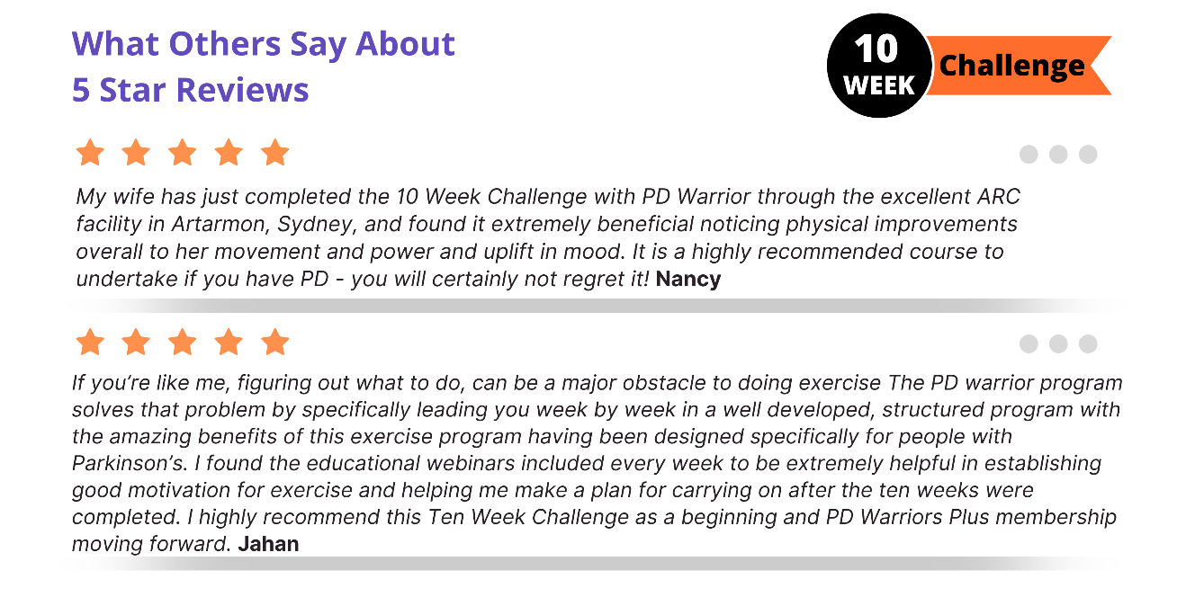

SIGN ME UP

